Project Design Phase-II

Data Flow Diagram & User Stories

|  |  |
| --- | --- |
| Date | 03 October 2022 |
| Team ID | PNT2022TMIDxxxxxx |
| Project Name | Walmart Sales Analysis for Retail Industry  with Machine Learning |
| Maximum Marks | 4 Marks |

# Data Flow Diagrams:

A Data Flow Diagram (DFD) is a traditional visual representation of the information flows within a system.

A neat and clear DFD can depict the right amount of the system requirement graphically.

It shows how data enters and leaves the system, what changes the information, and where data is stored.

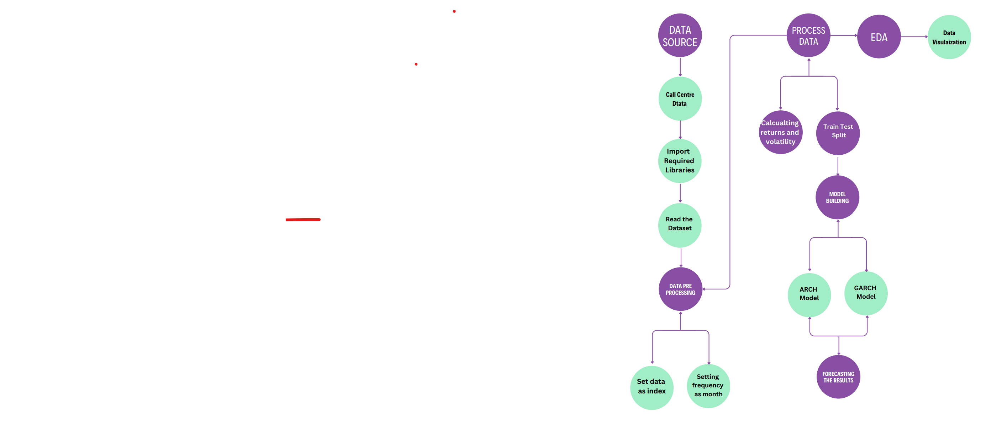

**User Stories**

|  |  |  |  |  |  |  |
| --- | --- | --- | --- | --- | --- | --- |
| **User Type** | **Functional**  **Requirement (Epic)** | **User Story Number** | **User Story / Task** | **Acceptance criteria** | **Priority** | **Release** |
| Customer (Retail Analyst) | Sales Analysis | WMSA-1 | Access Walmart sales data for a specific time period | View sales data for selected time period | High | Sprint-1 |
|  |  | WMSA-2 | Filter sales data by product category for analysis | View sales data filtered by product category | High | Sprint-1 |
|  |  | WMSA-3 | Generate visualizations (charts, graphs) based on sales data | Generate visualizations representing sales trends and patterns | Medium | Sprint-2 |
|  |  | WMSA-4 | Export analyzed sales data and visualizations for reporting | Export data in CSV or PDF format | Medium | Sprint-2 |
|  |  | WMSA-5 | Set custom alerts for specific sales thresholds | Receive notifications for defined thresholds | Low | Sprint-3 |
| Data Scientist | Data Modeling | WMSA-6 | Access raw Walmart sales data for machine learning modeling | Download raw sales data for machine learning analysis | High | Sprint-1 |
|  |  | WMSA-7 | Train machine learning models on Walmart sales data | Predict future sales trends through trained models | High | Sprint-2 |
|  |  | WMSA-8 | | Evaluate accuracy of machine learning models based on historical data | Assess model accuracy and adjust parameters as needed | Medium | Sprint - 4 |